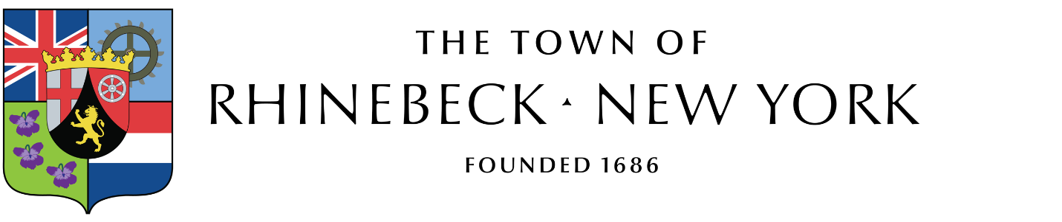

The Town Board of the Town of Rhinebeck will hold a Special Meeting on Monday, October 3, 2022 at 1:45 pm at the Rhinebeck Town Hall.
The purpose of this Special Meeting is to present the 2023 Tentative Budget, to schedule budget workshop meetings and any additional business that may arise.

Joan Winne
Town Clerk
September 27, 2022

